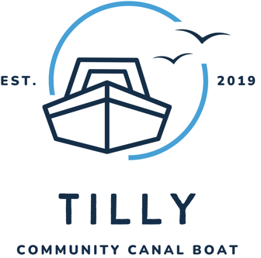

Tilly Canal Boat

HFR Solutions CIC is a not-for-profit organisation serving the Humber region.

HFR Solutions CIC provides safety solutions and rescue teams to businesses nationwide. We reinvest all our profits into the community and initiatives that match our vision. Tilly, the community canal boat, is one of our many initiatives.

- Tilly was built in 2019 and is moored at Stanilands in Thorne.
- We provide many day trips at no cost to community groups and welcome people of all ages and abilities. Our services are free of charge but not free of cost. Each trip costs £350, which HFR Solutions CIC supports. We ask for a donation towards running costs from anyone who can afford it so that we can offer more groups the opportunity to enjoy Tilly.
- Our canal boat is operated by our volunteer skippers and crew, who have undertaken nationally accredited training.
- Tilly has a lift to offer wheelchair access, and there is a toilet and a well-equipped kitchen on board.
- Group leaders are responsible for assessing the number of carers needed for each trip and ensuring that the number present is adequate. The skipper will give a health and safety briefing before the commencement of the trip. Group leaders are responsible for ensuring that their group follows these instructions. Our skipper on the day has the right to cancel or review the trip if he/she deems supervision inadequate.
- Our skippers and crew members will not tolerate any violence, abuse and threatening behaviour towards them or other members of the community and reserve the right to stop the trip at any time
- Children must be supervised by an adult at all times (particularly on the decks). This is the responsibility of parents and carers
- Smoking and alcohol are not permitted aboard, but we stop for half an hour during the trip.

Tilly Canal Boat Booking Form

About Your Group

Name of Group

Please tick your group type:

Charity
Community Group
Social Enterprise/CIC
Local Authority/Public Sector

Other: ___________________________

Who are your service users/members?

What are the aims of your organisation?

How do you fund your activities?

How will your group benefit from a trip on Tilly?

Please return form to: info@tillycommunitycanalboatcic.co.uk

