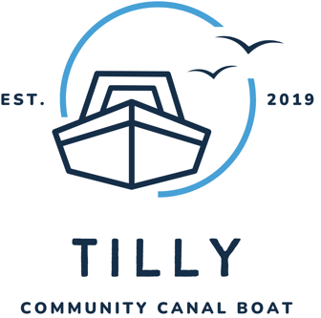

Tilly Canal Boat

Booking Details

Organisation Name:

Contact Name, Address, and Email:

Name:
Address:

Email:

Contact Details of Group Leader on the Day of the Trip:

Name:

Phone Number:

Provisional Dates (Maximum 4 per Year):

Preferred Meeting Time (default is 10:00 AM):

Number of Passengers in the Party (Max 12):

Carers/Support Workers:
Children (Under 16):
Mobility or Accessibility Needs:

Total:

Does anyone use a wheelchair? Yes / No – How many? (Maximum of 3 per trip)
(please see guidance on wheelchairs below*)

Any other mobility issues?

Any medical issues we should be aware of?

Additional Information:

Agreement

I confirm that I agree to the terms and conditions for Tilly trips as provided.

Signature: ___________________________ Date: ______________

Please return this form to:

info@tillycommunitycanalboatcic.co.uk

Useful Information for Your Trip

Duration: 4 hours
Location: Stanilands Marina, Lock Hill, Doncaster, DN8 5EP
What3Words: ///ballooned.framework.origin
Parking: Free parking is available near The Barge Inn, which has a large car park. Your vehicles can be parked at no cost on the marina grounds, but all vehicles, accessories, and contents are left at the owner’s own risk. HFR Solutions will not be responsible for their loss or damage.

Food: Drinks (tea, coffee, cordials, water) and biscuits are provided.
Bring a packed lunch or pre-arrange a pub stop (details available upon request).
*Wheelchairs: Due to safety issues, we count a wheelchair user as two people and can take a maximum of 3 wheelchairs on a trip. If you use a larger/heavier wheelchair, please let us know, and we will work with you to ensure ease of access wherever possible.

Lifejackets: All passengers under the age of 18 should wear life jackets at all times when on deck or temporarily leaving the boat. All other passengers should also wear lifejackets when temporarily leaving the boat.
.
Clothing: Flat, non-slip shoes; weather-appropriate attire. Please consider the time of the year and wrap up accordingly.
We hope you have a memorable trip on Tilly and if you have any queries, please feel free to contact us

